[1]  [2]

**LORANN**

**Project folder**

**Java/POO/UML**

*FRISCHMANN Florian, FOCA Tristan, GERMAIN Hugo 05/06/18*

Table of contents

**1. Introduction** 2

**2. Context** 2

**3. Objectives** 2

**4. Needs** 2

➢ Integrate all named resources into a database 2

**5. Presentation of the actors** 2

**6. Project’s Gestion** 3

**7. Planning and time management** 3

1. Provisional planning 3

2. Effective planning 3

3. Analysis of variances 4

**8. Communication tools and methods** 4

**9. Difficulties encountered** 5

**10. Developments** 5

1.Personnal 5

2.Group 5

### 

## **1. Introduction**

This file is intended to present the progress of the project, it is intended for tutors.

It lists the organization of this project, the individual and group returns as well as the difficulties encountered throughout the project

## **2. Context**

It is about rewriting an old game, dating from 1985, which was published for MO5 and TO7. LORANN is a PacMan type game, it evolves from square to square by picking up objects and avoiding being caught by monsters. The goal is to retrieve a key and reach the door while trying to retrieve the gold bags on the way.

## **3. Objectives**

* Complete the game program, five cards minimum
* Stored the levels in the database
* Implement the different resources available in the game

## **4. Needs**

* Realize the different modules given
* Create five different maps

## Integrate all named resources into a database

## **5. Presentation of the actors**

1. Florian Frischmann: Project Manager

2. Tristan Foca: Developer

3. Hugo Germain: Developer

## **6. Project’s Gestion**

For the organization of this project, we have chosen to divide the different tasks by themes:

* Programming:
* Different Modules

## **7. Planning and time management**

### 1. Provisional planning

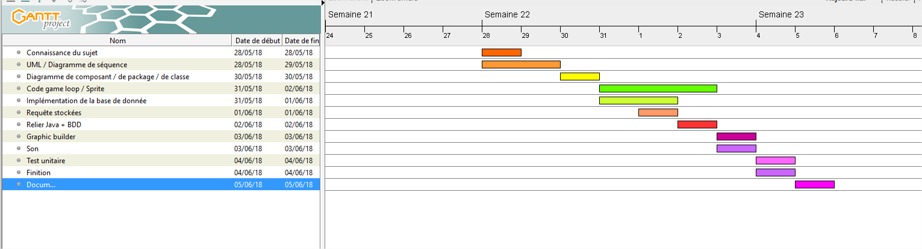

### 2. Effective planning

### 3. Analysis of variances

We noticed that some tasks could either be done easily or had to be done much earlier than we had predicted. We had also left on the fact that all would be done in.

The order by being well parameterized. But we underestimated some tasks and gave too much importance to others. In the end, the tasks were not completed in order and were completed quickly.

## **8. Communication tools and methods**

OneDrive:

We have set up a OneDrive folder to pool our work and centralize it.

Eclipse:

We used Eclipse to code.

PhpMyAdmin:

We used PHP to launch the database

GitHub:

We used GitHub to save code evolution

Gantt Project:

We used it simply to make the different schedules

Excel:

We used it to draw the different maps.

Visual Paradigm:

We used it to design our diagrams.

## **9. Difficulties encountered**

We, of course, had trouble with the code. We had to enter the values of the cards by hand into the database and we got tangled several times which delayed us a lot. We wanted to add music inside the game, but we faced reading errors.

We also had problems with the layout of the background in the cards

## **10. Developments**

* Add music; one for the menu, for the game, for the GameOver
* Add more maps
* Optimize maps, make maps smarter

**11. Balance sheets**

### 1.Personnal

Hugo: This project was hard but also interesting, I was in charge of the "Controller" part of the program and I found it very interesting. Coordination with the members of my group was essential because we were a group of three.  
However, we have encountered an error that we cannot correct while all the parts, the DB and the queries are working, this is necessarily very frustrating, and I hope we will find a solution.

Tristan: This project was very interesting thanks to the skills required to end it, I really appreciated to handle the model and DB parts what were real objectives for me. Unfortunately, a "untraceable" error in this parts of the code prevents the execution of the program, then, I spent a lot of time to fix it... But more generally, the project was pleasant to realize despite the difficulty of this one. This project allowed me to improve me largely in the object-oriented programming and so in the language Java.

Florian: This project was interesting. I do the « View » a part of the program. That wasn’t very hard but despite there were some errors   
I also take care of the database something not difficult but extremely long. Otherwise the atmosphere was perfect, the coordination was great.

### 2.Group

The group worked very well, indeed, everyone tried to carry out its tasks properly and effectively. All in caring and with good cohesion. All the unforeseen problems were easily overcome by the fact that all the members of the group supported each other.

1.
2.